International Movement of Catholic Students
IMCS - Pax Romana - MIEC

Report of the UN Advocacy Team

2016 – 2017

Table of Contents

Introduction

Process Cluster 1- 2030 Agenda and High Level Political Forum

Process Cluster 2- HABITAT III

Process Cluster 3- World Humanitarian Summit

Process Cluster 4- Youth Development and ICMYO

Process Cluster 5 - UN General Assembly, CSocD, and CSW

Process Cluster 6- Disaster Risk Reduction

Process Cluster 7- Financing for Development

Process Cluster 8- Science-Policy Interface

Process Cluster 9- United Nations Conference on Trade & Development

Process Cluster 10- ECOSOC Youth Forum

Other Notable Events

Conclusion

Introduction

In the 2015-2016 year, a new era of sustainable development began, thus catalyzing a paradigm shift in the way human development is approached to go beyond “business as usual.” As such, the UN Advocacy Team has had a busy and productive year, keeping track of new processes, ensuring adequate reflection of youth priorities in intergovernmental frameworks, and expanding the space for youth participation and engagement within the United Nations. With the beginning of this new era of sustainable development, the year 2015 saw the adoption of four major global frameworks: the 2030 Agenda for Sustainable Development, the Sendai Framework for Disaster Risk Reduction, the Addis Ababa Action Agenda (official outcome of the 3rd Financing For Development Conference), and the COP21 Paris Climate Change Agreement.

This pace of advocacy and involvement has continued into 2016, especially with the World Humanitarian Summit and the final preparations for the 3rd UN Conference on Housing and Sustainable Urban Development - Habitat III, along with all other processes in which the team is formally engaged. From New York to Sendai, from Addis Ababa to Istanbul and beyond, the UN Advocacy Team was able to take the message of IMCS - Pax Romana and its millions of members to political negotiations, UN meetings, NGO trainings, and other important events throughout the year. Today, the hard work and efforts of the members of the UN Advocacy Team means that young people are moving closer to creating a youth-led and youth-based advocacy infrastructure in New York that can serve IMCS, ICMYO, the UN Major Group for Children and Youth (UN MGCY), and all other civil society partners for years to come. The UN Advocacy Team is laying this bedrock by acting as the first official ICMYO Liaison to the UN, as well as expanding the ICMYO representation on the ground, and taking a leading and primary role in the UN MGCY. It is with great pride that the UN Advocacy Team presents this report and hopes the International Teams of the Pax Romana movement will accept and share it with all regional coordinators and national movements.

This report is organized into process clusters of events and meetings. This is primarily because many of the meetings in which the UN Advocacy Team participated were part of larger policy processes. As a result, it is much simpler to read about the activities of the team.

Process Cluster 1: 2030 Agenda and the High Level Political Forum

The Open Working Group (OWG) on the Sustainable Development Goals (SDGs) paved the way to a series of Intergovernmental Negotiations (IGNs) that worked toward developing a zero draft of the 2030 Agenda while articulating the means of implementation, follow-up and review of the SDGs. The UN Advocacy Team helped to prepare statements that would secure space for children and youth, amongst other Major Groups and Stakeholders, in the Agenda for 2030. Furthermore, the Team was instrumental in advocating for the inclusion of antibiotic resistance in SDG 3, clearer articulation of gender equality and access to quality and free primary/secondary education for all, an inclusive and citizen-driven follow-up and review mechanism, and beyond.

The 2015 year was one of transformative change. The 70th session of the United Nations General Assembly set a historic precedent by ushering in a new era of sustainable development. This UN Sustainable Development Summit saw the 193 member states adopt, celebrate, and make commitments to the new Sustainable Agenda for 2030. The 17 SDGs are a commitment to build from the Millennium Development Goals to “leave no one behind” and close the gap of inequality and inequity, locally and globally, by engaging all people, everywhere. The SDGs are integrated and indivisible, balancing the three dimensions of sustainable development: economic, social, and environmental, thus establishing a framework for development over the next 15 years.
As young people, representing up to half of the world’s populations, we are torchbearers of the agenda as we will be the ones held accountable for implementing in its entirety and ensuring its continuity into the next generation. We have the potential to make change, but must be given the proper tools and resources to meaningfully participate in the design, implementation, monitoring, review, and reporting of policies. The outcome of our actions will not be driven by the “world we want”, but rather by the “world we deserve.”

During the process leading up to this summit, the UN Advocacy Team helped in the drafting of UN MGCY statements during the monthly IGNs, lead capacity building workshops (UN MGCY Youth Blast), and took a leading role in bilateral meetings with Member States and UN agencies. During the Summit to Adopt the SDGs, the Advocacy Team assisted the UN MGCY in the drafting of and delivery of statements at events parallel to UNGA events. This helped strengthen the engagement of youth and positioned the youth voice and youth-led organizations in the midst of the discussion.

The High Level Political Forum

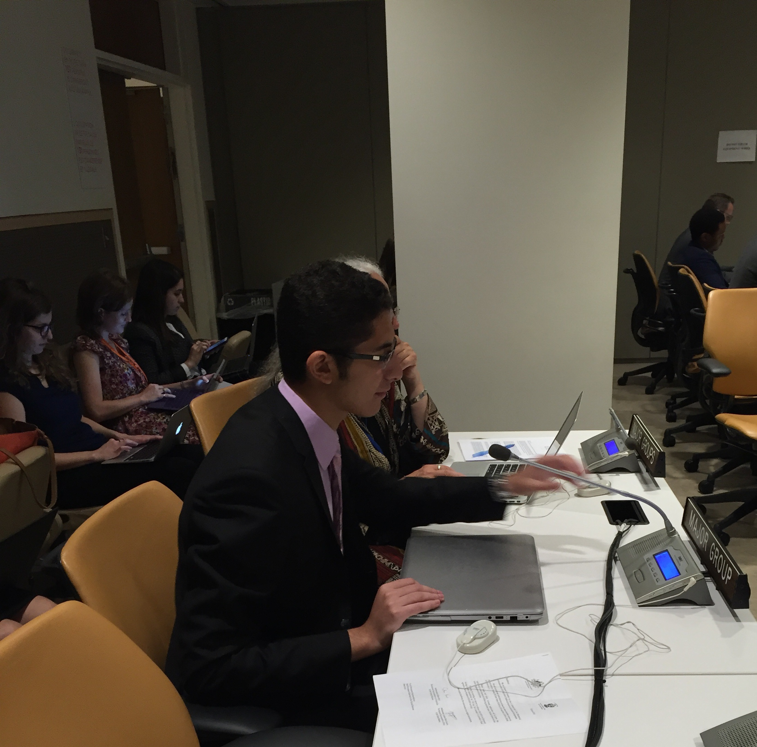
Sameh Kamel, member of the IMCS Pax Romana UN Advocacy Team at negotiations during the 2016 HLPF

The HLPF is the body that is meant to oversee the implementation and review of the SDGs. It was established through the consensus of the UNGA at Rio+20 through resolution 67/290 to replace the faltering and weak UN Commission for Sustainable Development (CSD). The HLPF is a complex entity as it alternates between being under the auspices of the UNGA and ECOSOC. It, however, also provides an unprecedented amount of levity to Major Groups and other Stakeholders to directly engage the follow-up and review process. As such, the UN Advocacy Team has played an active role in the past four meetings of this very important body.

At the third meeting of the HLPF in July 2015, which took place under the auspices of ECOSOC, there was a bit of a fight to make sure that civil society would continue to play a meaningful role in the monitoring and implementation of the 2030 Development Agenda. In order to facilitate the participation of Major Groups and other Stakeholders in the HLPF, a small MGoS working group was convened. Through the UN MGCY, the UN Advocacy team was very active in this working group, and played a key role in several of its functions, including: selecting MGoS speakers for the 2015 HLPF, organizing the first ever MGoS pre-HLPF workshop, as well as volunteering for the politically difficult task of summarising the outcomes of this workshop in a report to UN DESA -- to the satisfaction of all parties involved. A member of the Un Advocacy team, Marwan Bishtawi, was was invited to speak at the opening roundtable of the HLPF on behalf of the entire MGCY.

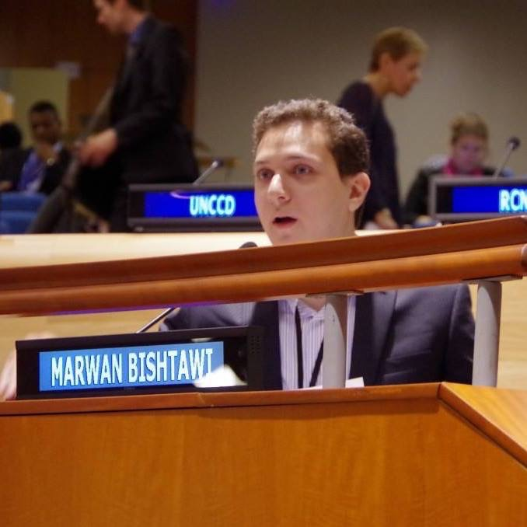
Marwan Bishtawi, Member of the IMCS Pax Romana UN Advocacy Team delivering a statement on behalf of the MGCY
At the most recent meeting of the HLPF in July 2016, which was also held under the auspice of the ECOSOC, the previous year’s struggle to maintain MGoS participation continued. The UN Advocacy Team was intensely involved in drafting and delivering statements on behalf of the UN MGCY during the Ministerial segment IGNs of the HLPF. In addition to fighting to maintain the UN-mandated space for Children and Youth participation at the HLPF, UN Advocacy Team member Sameh Kamel articulated children and youth positions during these IGNs. Thus, once again, the UN Advocacy Team proved to be an invaluable member of the UN MGCY, and its work crucial to the continued representation of youth and youth priorities at intergovernmental processes.

President of the General Assembly Dialogues on the Post-2015 Development Agenda Negotiations

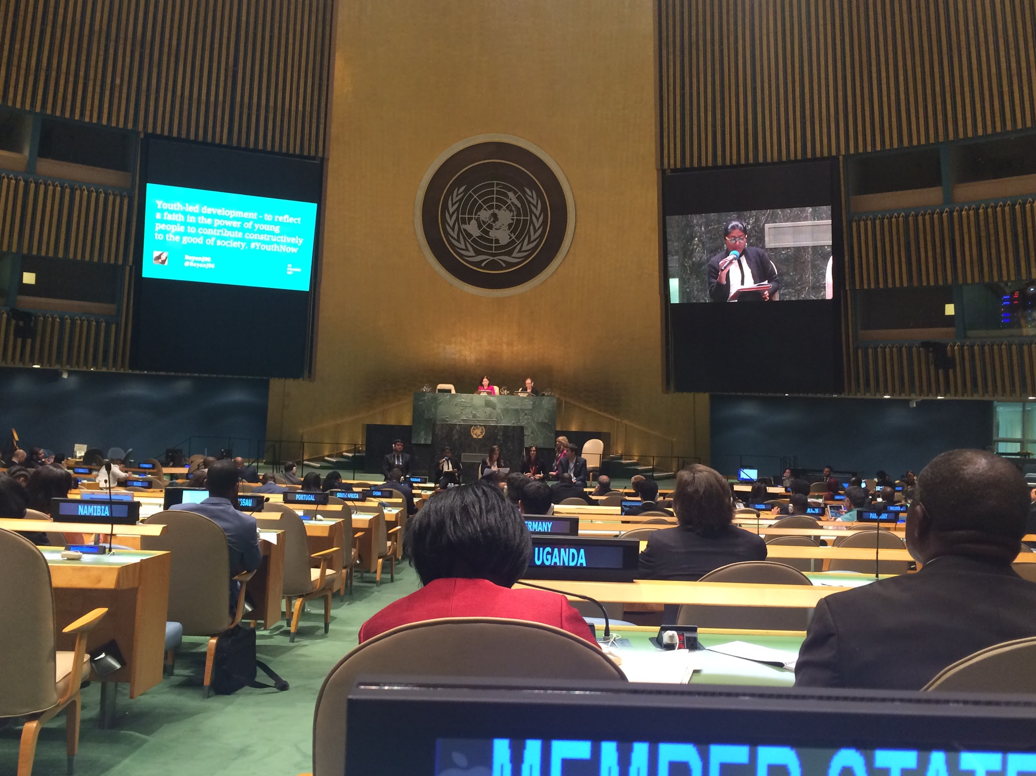
The President of the General Assembly (PGA) Sam Kutesa of Uganda maintained his predecessors’ precedent of reaching out to stakeholders for their views on the Post-2015 Development Agenda Negotiations. As a result, he hosted a number of dialogues with Member States, the UN, major groups, and other stakeholders. The dialogues revolved around a number of key issues from the negotiations. Thanks to the efforts of the UN Advocacy Team, IMCS - Pax Romana had two speakers present during that dialogue: One on behalf of ICMYO and one on behalf of the UN MGCY. Patrick Ochiba of the IMCS Pan-African Coordination spoke of the local and regional development work and experiences of our movement in Africa, while Marina D’Costa of AICUF India spoke about how to bring global policy down to the work of local organizations.

Synthesis Report of the Secretary-General on the 2030 Agenda

The release of the UNSG’s synthesis report on the 2030 Agenda, entitled The Road to Dignity by 2030: Ending Poverty, Transforming All Lives and Protecting the Planet, was a milestone in the post-2015 process. It has helped to frame the negotiations and gave insights into how best to move forward on the overall agenda. The UN Advocacy Team, as part of the MGCY, worked with the Office of the Secretary General’s Envoy on Youth to submit additional inputs prior to the release of the report.

WE HAVE TO DISCUSS ALL OF OUR EFFORTS AROUND THE FORMATION OF THE HLPF MGoS COORDINATION MECHANISM!!!

Process Cluster 2: Habitat III

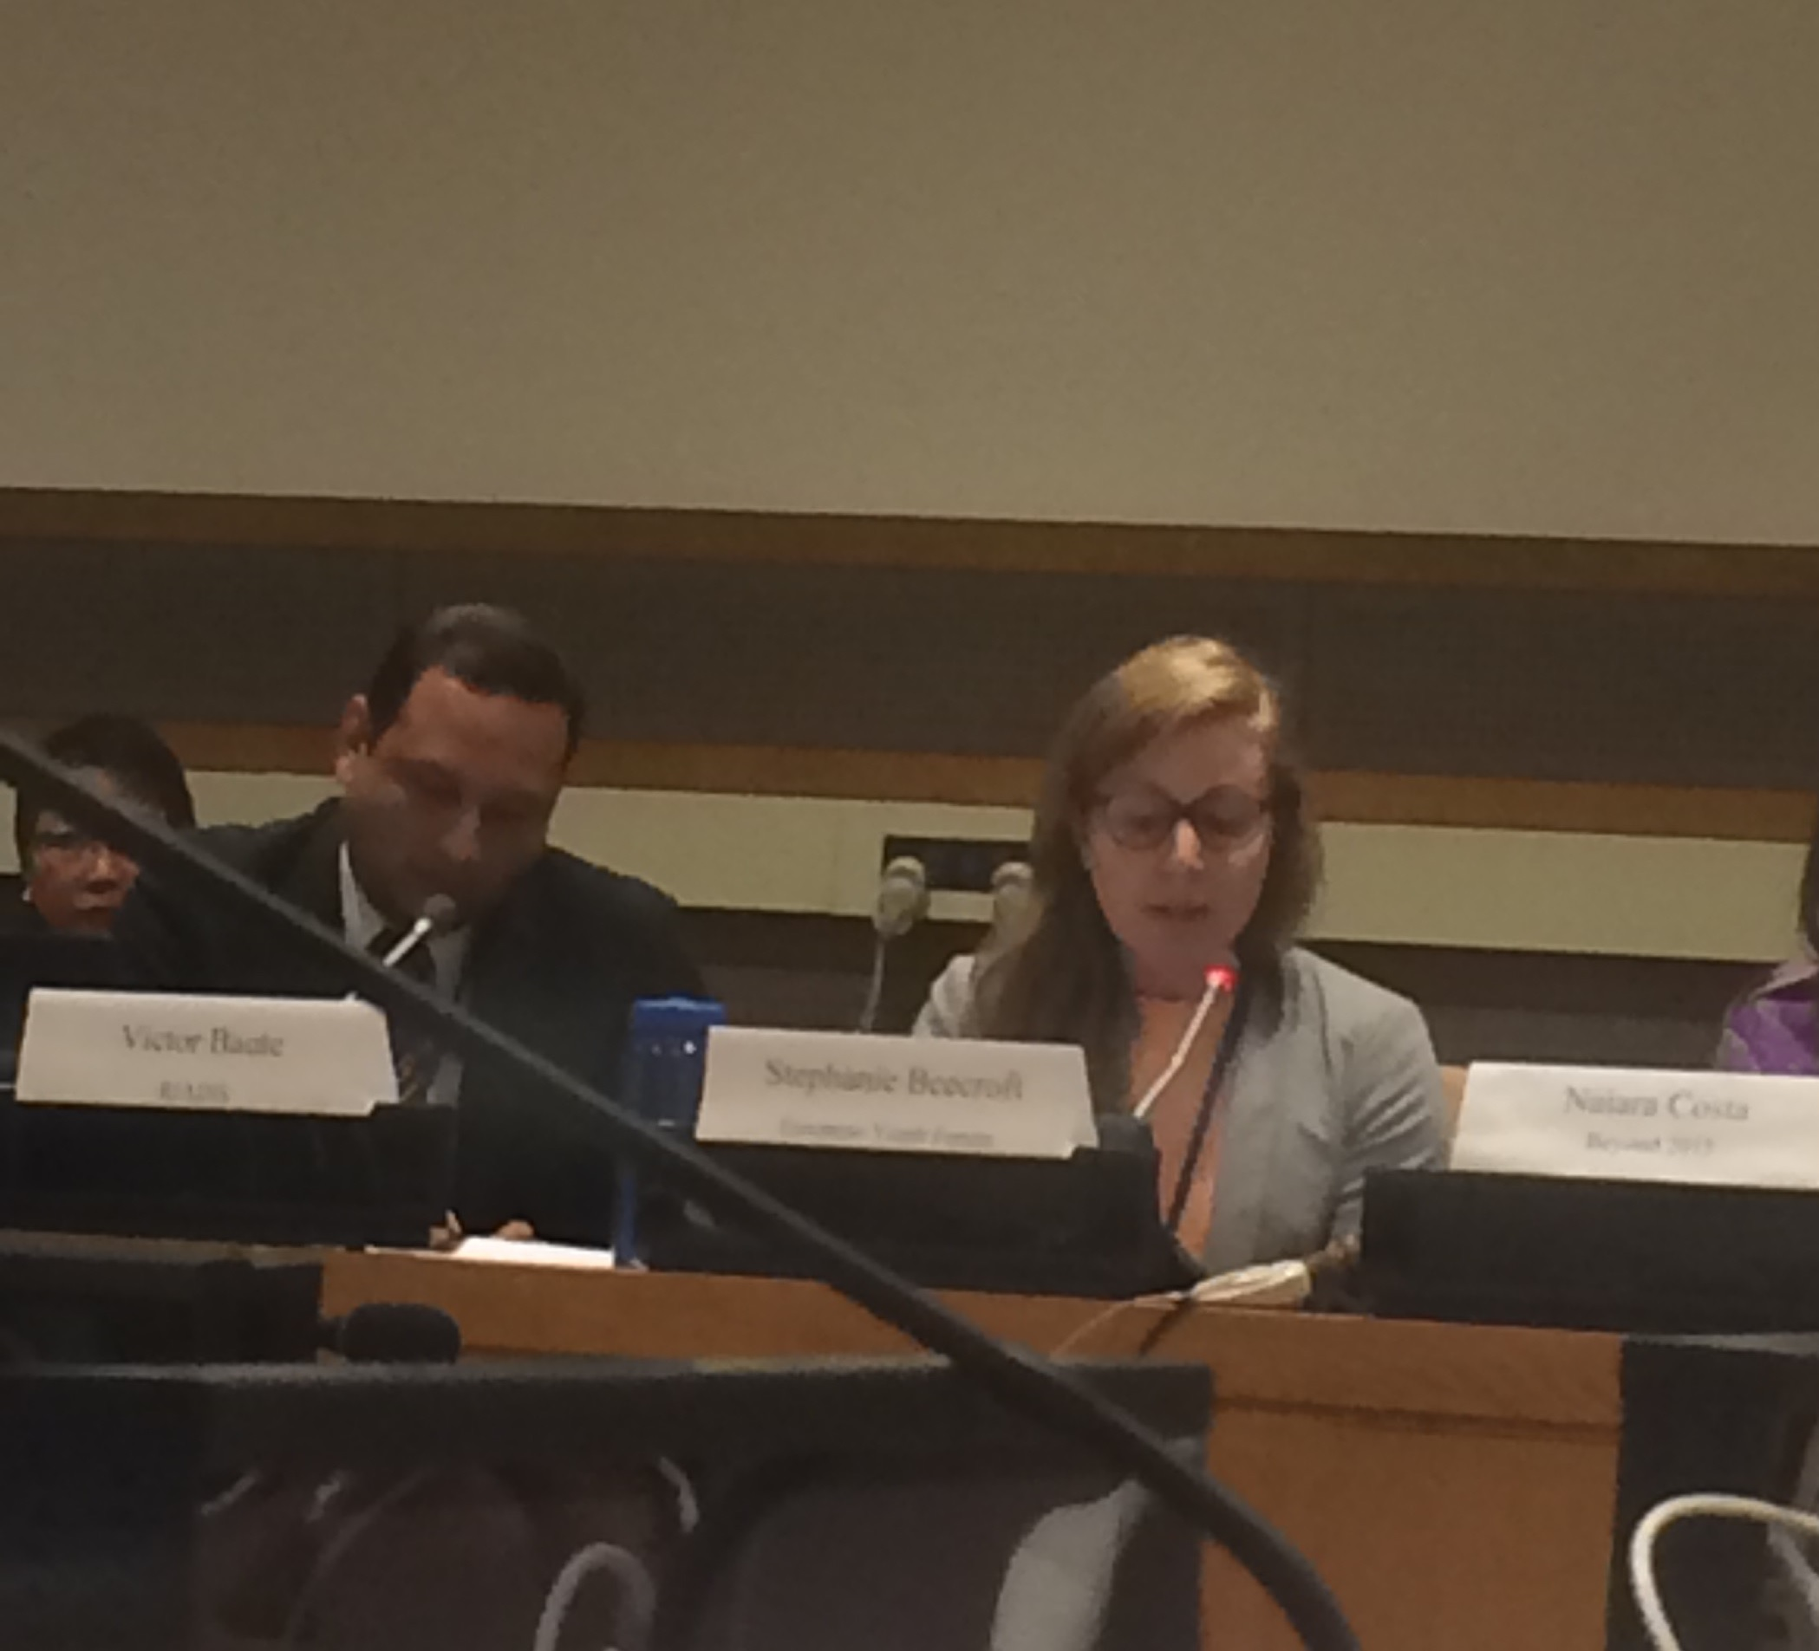

The UN Advocacy Team helps deliver the MGCY statement for HABITAT III
HABITAT III, the next step in the UN’s global sustainable development policy framework, will culminate in a United Nations intergovernmental conference in Ecuador (October 2016) to develop a New Urban Agenda and renewed political commitments towards a sustainable urbanization framework that promotes more resilient and inclusive cities.

Urbanization is a major driver of development and poverty eradication, however it must take into account the social, economic, and environmental dimensions that make up urban spaces to ensure resilient, inclusive cities, and sustainable cities. Urban spaces have seen unprecedented growth, with over 50% of the world’s population living in cities and projected to rise to 75% by 2050. Although they comprise 2% of the world’s total land, cities account for 70% of economy (GDP), over 60% of global energy consumption, 70% of greenhouse gas emissions, and 70% of global waste. Urbanization is inextricably linked to basic services such as health and education, changes in climate, disaster risk reduction, and more. To highlight its importance, the SDGs call for cities and human settlements to be safe, inclusive, resilient, and sustainable, using both existing structures and innovation to meet future needs.

Through an intergovernmental consultative process with stakeholders, including subnational governments, the goal is to secure renewed political commitments for sustainable urban development and assess accomplishments to date, while identifying and addressing new and emerging challenges.

The UN Advocacy Team has been and continues to be active in the work of UN MGCY in the Habitat III process, particularly in the context of the General Assembly of Partners (GAP), the stakeholder coordination mechanism of Habitat III. The UN Advocacy Team has worked closely with the UN MGCY within the Children & Youth Partner Constituency Group to mobilize the role of young people and reflect youth positions in the negotiations towards the New Urban Agenda. The UN Advocacy Team has helped in preparing statements during negotiations, planning capacity building events, and facilitating open-ended consultations on the Habitat III Process. This is an effort to promote discussion in order to generate a diverse set of suggestions from youth coming with unique backgrounds and perspectives, ensuring their thoughts are reflected in the Habitat III process.

IMCS Pax Romana helped organize and facilitate several consultations, including three in Cairo on October 28-29, 2015 and January 20, 2016, as well as one in Brooklyn’s at St. John’s College on May 5, 2016.

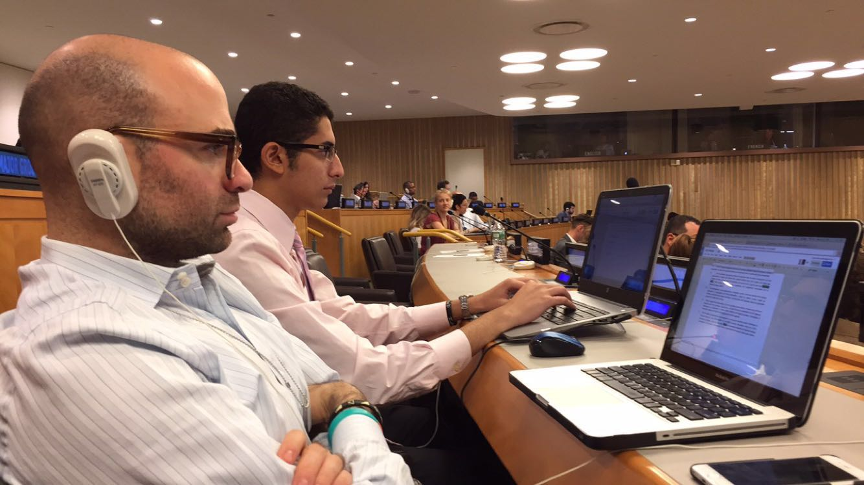
The UN Advocacy Team has also taken part in the drafting and delivering of statements on behalf of the Children & Youth PCG during the negotiations. The space is becoming increasingly political with the negotiations now focused on the initial zero draft of the New Urban Agenda, released April 2016, with a revised draft released June 2016 for further discussion. The discussions and advocacy is expected to continue into the PrepCom 3 in Surabaya at the end of July 2016 and with major decisions to be made at Quito and beyond. The UN Advocacy Team is adamant on pushing for an inclusive, multi stakeholder follow-up and review mechanism, setting the foundation for increased spaces for youth to engage in all aspects of the New Urban Agenda.

Process Cluster 3: World Humanitarian Summit

The World Humanitarian Summit (WHS), coordinated by the WHS Secretariat as part of the UN Office for the Coordination of Humanitarian Affairs (OCHA) took place in Istanbul on the 23-24th of May, 2016. The WHS aimed to reshape the global humanitarian agenda and address five core responsibilities: end and prevent conflict, respect rules of war, leave no one behind, working differently to end need, and invest in humanity. The UN MGCY, particularly through the leadership of the UN Advocacy Team, established a WHS Working Group as well as a Youth Task Force, coordinating youth involvement throughout the process.

The WHS Youth Task Force was a central player in organizing the Global Youth Consultation (GYC) for WHS, resulting in the Doha Youth Declaration on Reshaping Humanitarian Aid, of which UN Advocacy Team leader Christopher Dekki took part in drafting as a core member of the drafting committee. During the GYC itself in Doha, Qatar, the IMCS delegation was quite large, with members from Africa, Asia, and elsewhere participating, including the Pan-African and Asia Pacific Coordinators.

The UN Advocacy Team pre-WHS Youth Forum, which took place prior to the WHS and gave youth participant the opportunity to prepare and strategize around their participation. Christopher Dekki delivered a session on advocacy during the pre-WHS Youth Forum, and moderated a panel on making youth priorities a reality for the WHS.

During the WHS, several side events were co-hosted by UN MGCY. Christopher Dekki spoke at a side event on “Youth as Actors: Volunteering in Humanitarian Settings”. A plenary statement on the topic of humanitarian financing was delivered by IMCS - Pax Romana president Edouard Karoue.

The WHS Youth Task Force took part in the planning of the Special Session on Transforming the Humanitarian Agenda with and for Young People. Edouard Karoue took part in a roundtable during this special session. A Compact for Young People in Humanitarian Action was launched during the special session. The WHS Youth Task Force has been part of creating this Compact, that has been signed by over 60 different organisations, member states and UN agencies. The Compact was signed by IMCS-Pax Romana president Edouard Karoue during a signing ceremony that took place during the WHS.

Process Cluster 4: Youth Development and ICMYO

UN Inter-Agency Network on Youth Development

The UN Inter-Agency Network on Youth Development (IANYD), according to its website, consists of “UN entities, represented at the headquarters level, whose work is relevant to youth. The aim of the Network is to increase the effectiveness of UN work in youth development by strengthening collaboration and exchange among all relevant UN entities, while respecting and harnessing the benefits of their individual strengths and unique approaches and mandates.” Although the UN Advocacy Team works directly with many IANYD members, it has, on multiple occasions, worked with them collectively, particularly when it comes to planning panels, side events, and larger, more major events.

In 2015 and 2016, the UN Advocacy Team worked closely with the IANYD on a number of projects and events, including the ECOSOC Youth Forum.

ECOSOC Youth Forum

The 2014 ECOSOC Youth Forum took place in June at the UN. The forum was a two-day event that was divided into four sessions: Promoting Youth Employment – Creating Decent Jobs for a More Sustainable Future, Advancing progress in Africa beyond 2015, Youth: The Future They Want Beyond 2015, and the “Road Map:” Youth and the 2015 Development Summit. The UN Advocacy Team played mostly a support role during the forum, especially for ICMYO. Statements were delivered on behalf of ICMYO and the MGCY outlining positions in regards to the 2030 Development Agenda. Here, the team helped with the preparation of these statements and assisted with advocacy around these position.

UNDESA

As the permanent co-chair of the IANYD, the UN Focal Point on Youth, which falls under the UN Department of Economic and Social Affairs (DESA) Division of Social Policy and Development (DSPD), is ultimately the central player in the youth policy field. As a result, the UN Advocacy Team has made every effort to have a strong relationship with the UN Focal Point on Youth. For the most part, the team works with the Focal Point on Youth to help train and guide the UN Youth Delegates while they are in New York. Moreover, as the technical team that prepares all relevant resolutions on youth in the UNGA and ECOSOC, the UN Advocacy Team is always ready to provide inputs to these resolutions once negotiations begin.

Office of the UN Secretary General’s Envoy on Youth

The UN Advocacy Team has fostered a very positive relationship with the Office of the UNSG’s Envoy on Youth (OSGEY) on behalf of IMCS, ICMYO, and the MGCY. This has culminated in the inclusion of IMCS, ICMYO, and the MGCY in a number of projects, programs, and events hosted by the OSGEY. The current Envoy, Ahmad Alhendawi, is especially close to the members of the UN Advocacy Team, which means that the team is very often on the Envoy’s mind whenever he is in need of advice or consultation from youth-led organizations. The OSGEY was established in 2013 and began working on a number of projects throughout that ensuant years.

One of the major projects of the OSGEY is the Global Youth Call, which endeavored to gather youth positions on the 2030 Development Agenda from around the world. This massive online crowdsourcing platform became a critical input into the post-2015 process. It covered a number of thematic areas, like governance, health, and employment. The UN Advocacy Team was asked to take the lead on the governance theme on behalf of ICMYO. Working with UNDP and Restless Development, the UN Advocacy Team helped guide the work of ICMYO and collected the many inputs young people made on the topic of governance. The team also did some work on the employment theme as it was the MGCY that was tasked to take the lead there. The Global Youth Call was officially released at the 2013 ECOSOC Youth Forum.

Another major program of the OSGEY was the First Global Forum on Youth Policies in October 2013 in Baku, Azerbaijan. The Forum brought together youth ministers, youth practitioners, youth activists, representatives of UN and government entities, and youth-led organizations in an attempt to review youth policies on all levels and share best practices in the field of youth policy and development. The UN Advocacy Team played a leading role in the planning of this event. It helped the OSGEY in the selection of youth speakers and panellists and also facilitated the participation of ICMYO organizations and the MGCY. During the event itself, Chris co-moderated two sessions on youth participation with UNDP. Although the Forum did not produce a negotiated outcome, it created commitments and a way a forward for youth policy on all levels, including the beginning of the celebration of the 20th anniversary of the World Programme of Action on Youth (WPAY).

Process Cluster 5: Post 2015 summit / UN General Assembly

IMCS helped in planning and coordinating the youth blast

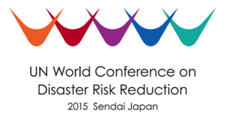
Process Cluster 6: Disaster Risk Reduction

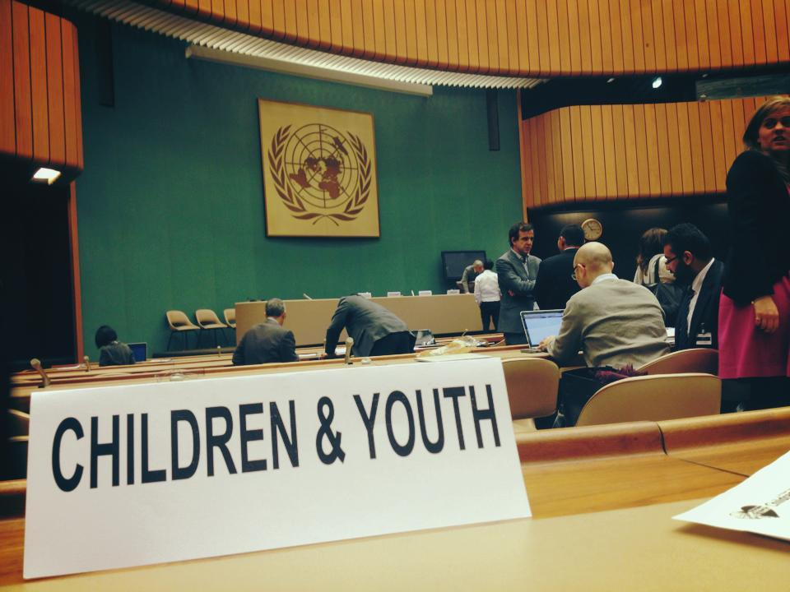
The World Conference on Disaster Risk Reduction (WCDRR) is the culmination of an intergovernmental process to create a 10 year framework on a global response to disaster risk reduction. The WCDRR is the second iteration of this worldwide effort around DR, the first being the process that established the Hyogo Framework for Action (HFA) in 2005. The outcome of the WCDRR is the Sendai Framework for Disaster Risk Reduction. The UN Advocacy Team has been active in the work of the UN MGCY around this process and participated actively in the negotiation process leading to the WCDRR.

At the World Conference on Disaster Risk Reduction (WCDRR) process, members of the UN Advocacy Team participated in and attended the World Conference on Disaster Risk Reduction in Sendai, Japan in March 2015. The DRR conference highlighted Major Groups as the primary vehicle for stakeholder engagement. Specific activities included facilitating sessions in the Children and Youth Forum in addition to participating in the formal segments of the meetings to carry out advocacy for young people as a youth-led organization. The final outcome has been highly influenced by the young people active in the DRR process through the MGCY. The UN Advocacy Team, because of its leadership in the UN MGCY, has been assisting with the UN MGCY’s advocacy, primarily through capacity building and lobbying.

Process Cluster 7: Financing for Development:

The UN Advocacy Team, since the very beginning, has been active in the work of the UN MGCY in the Financing for Development (FfD) process. In the summer of 2015, a number of meetings took place relating to the development of the final outcome of this process, the Addis Ababa Action Agenda (AAAA). During the negotiations in New York, the UN Advocacy Team played a central role in the work of the UN MGCY. Although the UN Advocacy Team did not attend the conference in Addis itself, it was able to help in planning some of the youth events that took place there, including side events and other sessions.

Process Cluster 8: Science-Policy Interface

The Science-Policy Interface (SPI) has become an increasingly important component of sustainable development within the United Nations system. It provides the foundation for empirically-based policies, facilitates the use of science as an enabler in policy implementation and review, and provides a unique scientific lens into monitoring impact. Furthermore, SPIs have been integral in identify emerging priorities, drawing links between the interconnected nature of thematic issues, and devising solutions to address challenges and barriers to progress. The Rio+20 outcome document - The Future We Want - solidified the role of SPIs and sought to operationalize its place within all sustainable development processes. Additionally, GA resolution 67/290 (which mandated the HLPF) seeks to strengthen the SPI by building on existing assessments, enhancing evidence-based decision-making at all levels, and contributing to the strengthening of ongoing capacity-building of statistical capacities. Such initiatives are meant to bring scientists and policymakers together to enrich policy design, implementation, and review by exchanging information, knowledge, and applications of technology and innovation.

The UN Advocacy Team has worked closely to help coordinate activities within the UN MGCY Youth Science Policy Interface Platform. Initiated in January of 2016 at the Science & Technology Conference for the Implementation of the Sendai Framework, it is meant to serve as a channel for young scientists, engineers, practitioners, and students--from both the social and natural sciences--to contribute to the science-policy interface within the UN system. The SPI platform is meant to strengthen youth policy and practice in sustainable development by equipping our generation with tools to drive empirically-informed, context-specific, and fit-for-purpose change through science, technology, innovation, and data. It seeks to close the divide at the science-policy-practice nexus to drive more empirically-based, data-informed development.

Recently, the Team were actively involved in the 1st Annual Science, Technology, & Innovation Forum for the SDGs, under the auspices of ECOSOC, taking place 5-6 June 2016. The team helped with drafting statements during each session and co-organize an official session on young scientist and innovators. It also co-hosted a roundtable discussion with other civil society members on “Leaving No One Behind - role of girls, women, indigenous knowledge, and informal systems in STI”, attended by members of the UN MGCY, Women Major Group, UNESCO, OSGEY, and more. Furthermore, the UN Advocacy team helped organize a side event on building coherence between the SPI initiatives between different sustainable development agendas. This is part of a larger discussion both within our policy work and the long term positioning of the UN system on how to best align the different agendas for effective, inclusive, and impactful change.

Engagement in the Youth SPI Platform will continue into the 2016 HLPF, as the UN Advocacy Team supports the UN MGCY in developing a pilot edition of a Youth SPI Publication, a compilation of briefs and articles submitted by young scientists and practitioners that will be compiled into a magazine-like publication. Additionally, this will be used to feed into the SPI discussions at the HLPF, as well as the Global Sustainable Development Report.

Process Cluster 9: United Nations Conference on Trade and Development

The 2016 UNCTAD Conference and Youth Forum will be held July 17-22 at the Kenyatta International Convention Center in Nairobi, Kenya. The UN MGCY is working closely with the UNCTAD 14 Secretariat to help facilitate the first UNCTAD Youth Forum in order to ensure a meaningful youth-led process.

The main objectives of the conference are as to identify the role of trade in contributing to the effective implementation of and follow-up to the 2030 Agenda for Sustainable Development, and relevant outcomes from global conferences and summits, as related to trade and development.
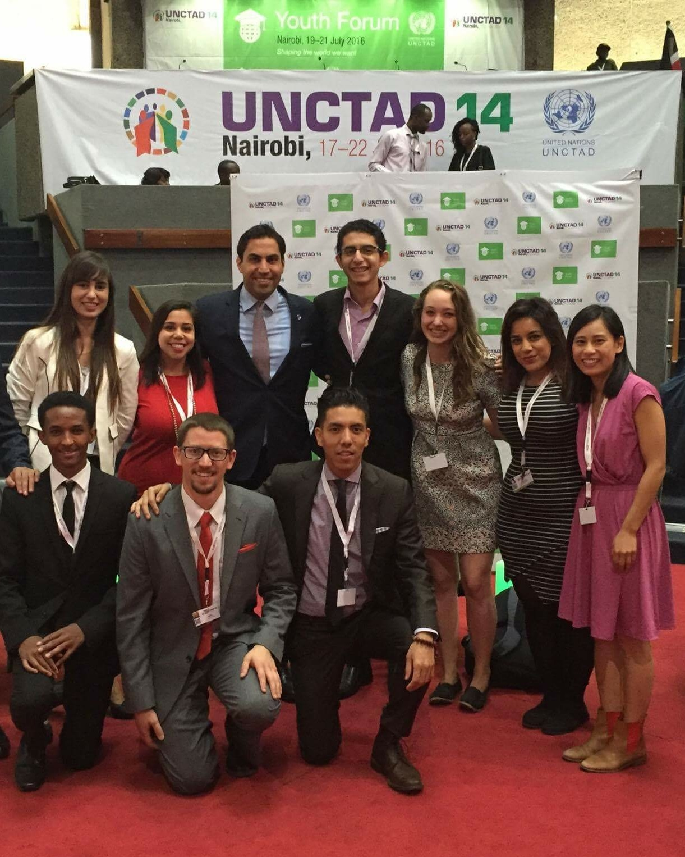
Ahmad Al Hendawi, UN Secretary General’s Envoy on Youth with Sameh Kamel and other MGCY members
The Youth Forum will be following the theme of “The World We Want” giving a voice to the youth to be part of this discussion by offering them a platform where they can share their views and ideas on issues that matter to them and that are related to the organization’s work. The outcome of the discussions was incorporated into a Youth Declaration that was presented by the youth to eminent UNCTAD 14 participants during the Forum’s high-level Ministerial session. The UN Advocacy Team has contributed by coordinating selection of a UN MGCY delegation, as well as sharing best practices on facilitation and drafting the Youth Declaration. Furthermore, members of Pax Romana attended - including Sameh Kamel and Ochiba Muchalwa Patrick - who facilitated breakout sessions during the Youth Forum on topics such as Education from the Public and Private Sector’s Perspective and Health, etc.

Other Notable Events

United Nations Alliance of Civilizations - EF Summer Schools (2015)

Chris has played and continues to play a leading role in the UNAOC - EF Summer Schools, the UNAOC’s training workshop for young social entrepreneurs. Chris conducts trainings on advocacy, especially advocacy around the UN and the SDGs. Chris has also played a central part in helping to expand the Summer School to include more youth activists coming through other UNAOC youth programs, like the Youth Solidarity Fund. Chris will continue to support the Summer School and other UNAOC events as to maintain the strong relationship IMCS has with the UNAOC.

International Federation of Medical Students Associations General Assembly (2016)

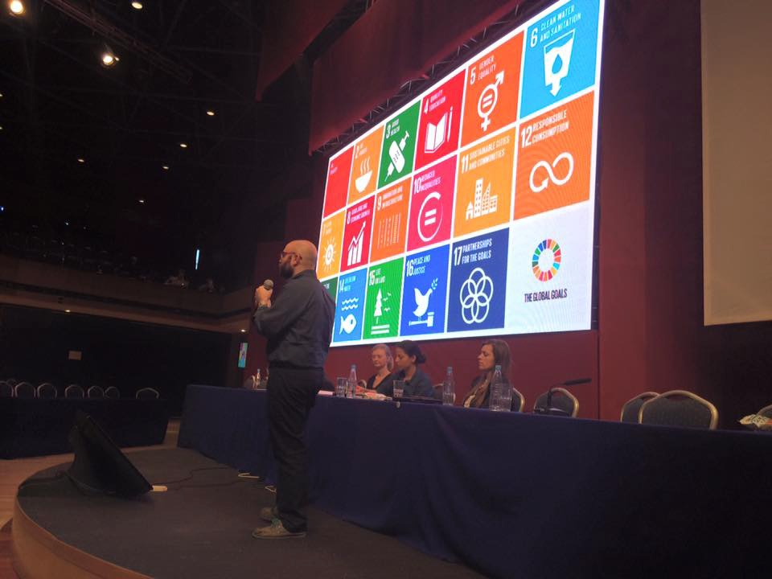

Chris was invited by the International Federation of Medical Students Associations (IFMSA), one of our strongest ICMYO partners, to speak and present at one of their general assemblies. The topics of his presentations included advocacy in intergovernmental processes, the SDGs, and other critical sustainable development frameworks.

Conclusion
The UN Advocacy Team has been extremely productive and has been able to further promote the importance of the movement at the global level. Nevertheless, a transition is certainly needed. New young people, empowered by the movement and trained by the current team, can help ...

UNMGCY, UN Major Group of Children and Youth intervention at HLPF 2015 Round Table 2, http://childrenyouth.org/blog/2015/06/26/shaping-the-world-of-2030-from-vision-to-transformative-action/
Synthesis Report of the Secretary-General on the Post-2015 Agenda, The Road to Dignity by 2030: Ending Poverty, Transforming All Lives and Protecting the Planet, http://www.un.org/disabilities/documents/reports/SG_Synthesis_Report_Road_to_Dignity_by_2030.pdf.
United Nations Inter-Agency Network on Youth Development, Overview, http://social.un.org/youthyear/unianyd.html.
The Global Partnership for Youth in the Post-2015 Agenda, The Global Youth Call: Prioritizing Youth in the Post-2015 Development Agenda, http://www.un.org/youthenvoy/wp-content/uploads/2014/09/The_Global_Youth_Call.pdf.
1st Global Forum on Youth Policies, Baku Commitment to Youth Policies, http://youthpolicyforum.org/documents/commitment.pdf.

